**DEBUGGING OF** **NOTE TAKING APPLICATION**

* Initially after setting up environment and installing the dependencies,when the app was run an error message was thrown that METHOD NOT ALLOWED(The method is not allowed for the requested url).
* The first bug which I can notice is methods which was defined as POST which needs to be changed to GET and POST.
* And also we need assign which method should be used,i.e if method == GET/POST.
* I have given the method as POST so that any sensitive information can be handled.And the same also needs to be included in the home.html.
* In order to get the information entered by the user from front end using post method we need to use request.form instead of request.args which Is yet another bug in the app.
* After making these changes the application is working fine and the user can add a note of their choice without any bugs.

**KEY CHANGES MADE:**

* **Methods = ‘GET’/’POST’**
* **Taking information from front end through post request.**
* **Request.form is used for post request.Hence request.args.get is changed to request.form.**
* **In home.html we have added method=post**

**CODE BEFORE DEBUGGING**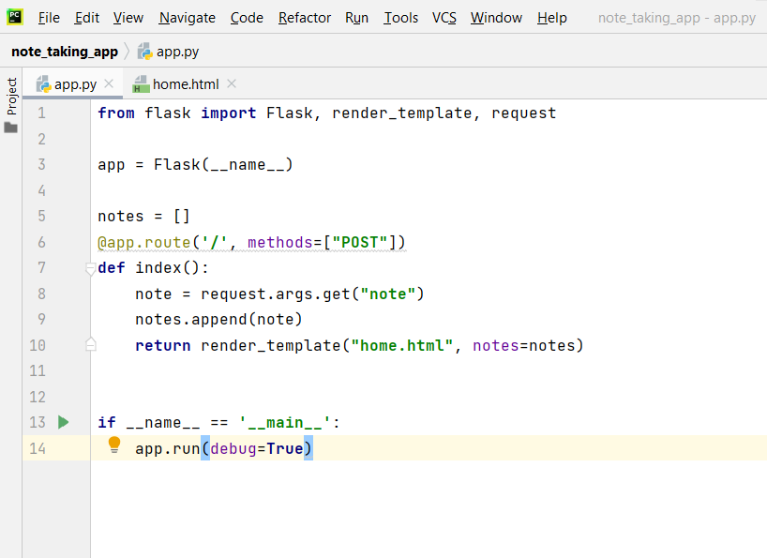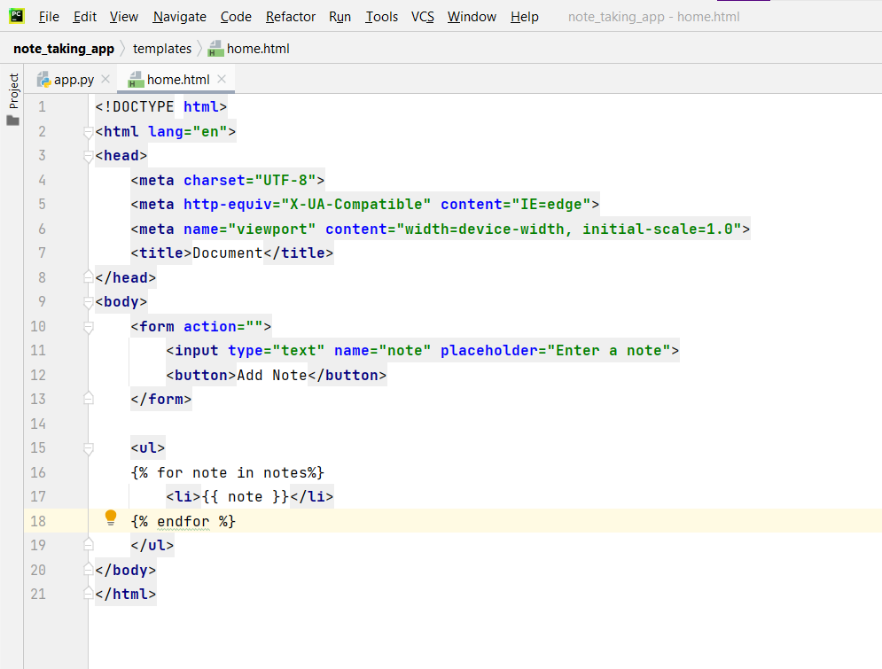

**CODE AFTER DEBUGGINGs**